This is a small Japanese Steakhouse and Sushi Bar business located in Philadelphia. We have scrapped data from this restaurant’s Facebook page to make some assumptions about Margaret’s.

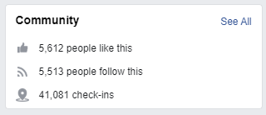<https://www.facebook.com/Hibachi-Japanese-Steakhouse-Sushi-Bar-219392908104243/>

Since this Facebook page has been up for 9 years, we assume that there are 10 people that check in per day based on the total number of check-ins. According to **Appendix XYZ**, 2% of restaurant diners will check in through Facebook. That means there are around 500 customers per day.

Conclusion: There are 500 assumed customers per day at our Hibachi restaurant